Name ____________________________
WWI Propaganda Formative Assessment
In this lesson, we have been learning how propaganda led to the outbreak of World War I. We have also learned how propaganda was used to support the war effort by encouraging patriotism, fear of the enemy, and calling on young men to fight. We have analyzed several propaganda images together, but it is your turn to show me how well you understand propaganda and its uses in declaring and waging war. Please use the following images to answer the questions on page 2.
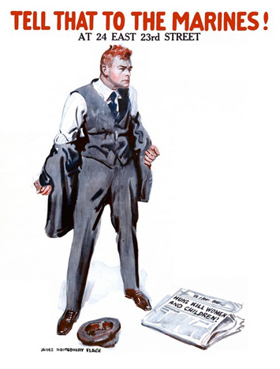
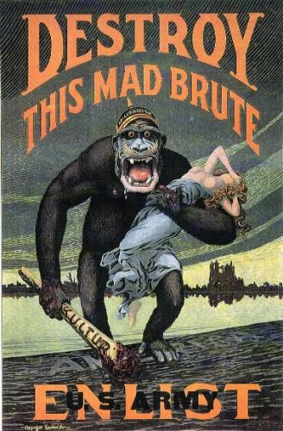
DOCUMENT 1: In this poster we see an ape-like creature, half-crazed and baring fangs, carrying a swooning woman. This creature carries a club that has “KULTUR” written on it. Based on the German helmet on the creature’s head and his straddling of a type of border that reads “America,” we can assume that the creature is symbolic of Germany. The viewer is meant to see Germany leaving destruction behind, and carrying away the innocent, after an attack on the homeland.

DOCUMENT 2: In this poster we see an angry man ripping off his jacket after reading the newspaper headline at his feet: “Huns Kill Women and Children.” The man almost seems to be ready to put on a Marine uniform right now. The newspaper headline refers to the Germans as “Huns” to evoke memories of past German aggression.

Name ____________________________
WWI Propaganda Formative Assessment (Typical)

- What is propaganda? Give a brief description of how it works.
____________________________________________________________________________________________________________________________________________________________________________________________________________________________________________________________________________________________________________________
- Do you think wartime propaganda is based on factual information? Why or why not?
____________________________________________________________________________________________________________________________________________________________________________________________________________________________________________________________________________________________________________________
For both of the propaganda posters attached, answer the following.

- Was America, Germany, or Great Britain the enemy in these two posters? What do you think the author’s opinion of the enemy was?
____________________________________________________________________________________________________________________________________________________________________________________________________________________________________________________________________________________________________________________
- Which of the following is the authors’ main purpose in using the slogans “Destroy the Mad Brute” and “Huns Kill Women and Children?”

  - To make the enemy look bad
  - To encourage Americans to join the war effort
  - To scare the reader
  - To argue that apes are hurting women

- Think about the point the authors were trying to make with these propaganda posters. Were you persuaded? Why or why not?
____________________________________________________________________________________________________________________________________________________________________________________________________________________________________________________________________________________________________________________

