Name ____________________________
Propaganda Formative Assessment
In this lesson, we have been learning how propaganda led to the outbreak of World War I. We have also learned how propaganda was used to support the war effort by encouraging patriotism, fear of the enemy, and calling on young men to fight. We have analyzed several propaganda images together, but it is your turn to show me how well you understand propaganda and its uses in declaring and waging war. Please use the following images to answer the questions on page 2.
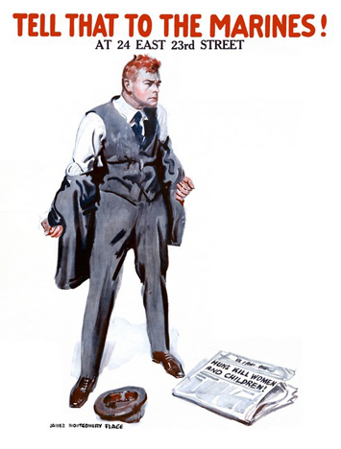
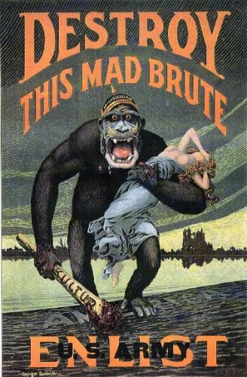
DOCUMENT 1: In this poster we see an ape-like creature, half-crazed and baring fangs, carrying a swooning woman. This creature carries a club that has “KULTUR” written on it. Based on the German helmet on the creature’s head and his straddling of a type of border that reads “America,” we can assume that the creature is symbolic of Germany. The viewer is meant to see Germany leaving destruction behind, and carrying away the innocent, after an attack on the homeland.

DOCUMENT 2: In this poster we see an angry man ripping off his jacket after reading the newspaper headline at his feet: “Huns Kill Women and Children.” The man almost seems to be ready to put on a Marine uniform right now. The newspaper headline refers to the Germans as “Huns” to evoke memories of past German aggression.

Name ____________________________
Propaganda Formative Assessment

- ___________ is a mode of communication in which one group attempts to influence the behavior or opinions of another, usually to support a particular agenda.
- Advertising
- Propaganda
- Rhetoric

- True or false. Wartime propaganda is most often based on factual information.

For both of the propaganda posters attached, answer the following.

- What country is this propaganda aimed towards?
  - America
  - Germany
  - Great Britain

- Propaganda during the First World War used slogans such as “Destroy this Mad Brute” to:
  - Get people to join the army
  - Get people to hate the enemy
  - Protect the civilians (women and children) at home
  - All of the above

- Both of these propaganda posters represent the Germans as a violent people who would destroy women and/or children. Which poster do you think would most persuade you to enlist to fight in the war? Check the reasons that persuaded you the most.

  - Document 1, because: (choose 3)
____ The enemy is an ape-like creature that is scary.
____ The creature has a club.
____ The creature looks like it is killing the woman.
____ The creature is wearing a helmet with the word “militarism.”
____ The poster says to “Destroy this mad brute.”
____ The poster says to enlist in the U.S. Army.
____ The creature is on the shores of America.

  - Document 2, because: (choose 3)
____ The man is angry and scary.
____ The newspaper says “Huns will kill women and children.”
____ The man is fed up and ready to fight.
____ The newspaper is thrown on the ground.
____ The man is ripping off his jacket.
____ I would want to fight the enemy, too.
____ The poster says to “Tell That to the Marines.”

